Jesus: Our Best Friend

Come and discover the BEST reason to love Jesus.

Lesson 4 Running Thread

1. PRAY
Lord Jesus. Thank you for being our Friend. Thank you for loving us and being with us. Help us to learn more about You and to love You more. Amen.

2. DID YOU KNOW?
Jesus is the fulfillment of God’s promises. His birth, mission and death were all foretold by the Prophet Isaiah about 600 years before Jesus was born.

Today, we find out why Jesus was sent by God to us.

3. READ

Luke 4:16-30 International Children’s Bible
Jesus Rejected at Nazareth
16 Jesus traveled to Nazareth, where he had grown up. On the Sabbath day he went to the synagogue as he always did. Jesus stood up to read. 17 The book of Isaiah the prophet was given to him. He opened the book and found the place where this is written:

18 “The Spirit of the Lord is in me.
This is because God chose me to tell the Good News to the poor.
God sent me to tell the prisoners of sin that they are free,
and to tell the blind that they can see again. Isaiah 61:1
God sent me to free those who have been treated unfairly, Isaiah 58:6
19 and to announce the time when the Lord will show kindness to his people.” Isaiah 61:2

20 Jesus closed the book, gave it back, and sat down. Everyone in the synagogue was watching Jesus closely. 21 He began to speak to them. He said, “While you heard these words just now, they were coming true!”

22 All the people praised Jesus. They were amazed at the beautiful words he spoke. They asked, “Isn’t this Joseph’s son?”

23 Jesus said to them, “I know that you will tell me the old saying: ‘Doctor, heal yourself.’ You want to say, ‘We heard about the things you did in Capernaum. Do those things here in your own town!’” 24 Then Jesus said, “I tell you the truth. A prophet is not accepted in his own town. 25 What I say is true. During the time of Elijah it did not rain in Israel for three and a half years. There was no food anywhere in the whole country. And there were many widows in Israel during that time. 26 But Elijah was sent to none of those widows. He was sent only to a widow in Zarephath, a town in Sidon. 27 And there were many with a harmful skin disease living in Israel during the time of the prophet Elisha. But none of them were healed except Naaman, who was from the country of Syria.”

28 When all the people in the synagogue heard these things, they became very angry. 29 They got up and forced Jesus out of town. The town was built on a hill. They took Jesus to the edge of the hill and wanted to throw him off. 30 But Jesus walked through the crowd and went on his way.

Isaiah 61 International Children’s Bible
The Lord’s Message of Freedom
61 The Lord God has put his Spirit in me.
This is because he has appointed me to tell the good news to the poor.
He has sent me to comfort those whose hearts are broken.
He has sent me to tell the captives they are free.
He has sent me to tell the prisoners that they are released.
2 He has sent me to announce the time when the Lord will show his kindness and the time when our God will punish evil people.
He has sent me to comfort all those who are sad.

4. WATCH

https://www.youtube.com/watch?v=PmO5v95fbEo

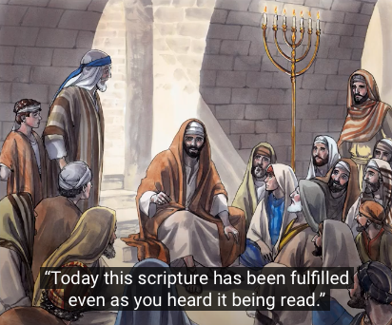

5. QUIZ
- What was the Book of the Bible that Jesus read from?

- Who was the Prophet talking about?

- What was the good news that Jesus told to the people?

- Why were the people angry?

6. ACTIVITIES

- Colour in Isaiah 61:1

- Make a booklet of this story of Jesus preaching at Nazareth (see attached file)

7. CLOSING PRAYER
Thank you Lord Jesus that you came to heal us and set us free. Thank you for being our Friend. Help us to know you more and to love others as you love them.

AMEN.

