Jesus: Our Best Friend

Come and discover the BEST reason to love Jesus

Lesson 6: Saying “Sorry”, Being Thankful

1. PRAY
Lord Jesus,
Thank you for being our Friend.
Help us to learn more about our special relationship with you.
Amen.

2. GET READY
Last week, we learnt of Jesus forgiving a paralyzed man his sins. Only God can forgive sins. Jesus must be God! To prove this, he also …. (do you remember ?) Amazing!

This week, we learn about someone who said “Sorry” to Jesus.

3. STORY

Look at the bottom of your shoes. Are they clean?

When Jesus was on earth, 2000 years ago, the roads were very dusty and people wore sandals. When you arrived at someone’s house, they would wash your feet. But when Jesus was invited to the house of Simon, a Pharisee, Simon didn’t do this. Someone else did. Who?

Luke 7:36-50
One day Jesus was invited to dinner by Simon. Simon thought himself a very important man. So Jesus went to the house and sat down to eat. While Jesus was eating, a woman came who had lived a bad life. We don’t know her name. She came in carrying a very special pot of perfume. Then she did something strange. She cried. Then she washed Jesus’ feet with her tears and hair, and poured the special perfume all over his feet. Then Simon thought to himself, ‘If Jesus was really a prophet, a person who hears things from God, he would know how bad this woman is who’s touching him.’
Jesus said to Simon, who thought he was a very important man, ‘I have something to tell you. There were two men who owed money. One man owed 500 silver coins. The other man owed 50 silver coins. Neither could pay, so the man who lent them the money said he would get rid of both their debts and forget about all the money they owed him. Who would love him most?’
‘I suppose the one who was forgiven most,’ said Simon. ‘You are right,’ said Jesus. ‘When I came to your house you did not wash my feet, but this woman has washed my feet with her tears and hair. You did not say hello to me with a kiss like people usually do, but this woman has kissed my feet. You did not put oil on my head, but this woman has covered my feet with perfume. All her sins are forgiven, and that is why she has shown me a lot of love. But anyone who has been forgiven only a little will only show a little love.’
Jesus turned to the woman and said, ‘Your sins are forgiven.’ All the other guests grumbled at this. Then Jesus told the woman to go and that God would give her peace.

4. WATCH

https://www.youtube.com/watch?v=II_v3KTtgDw

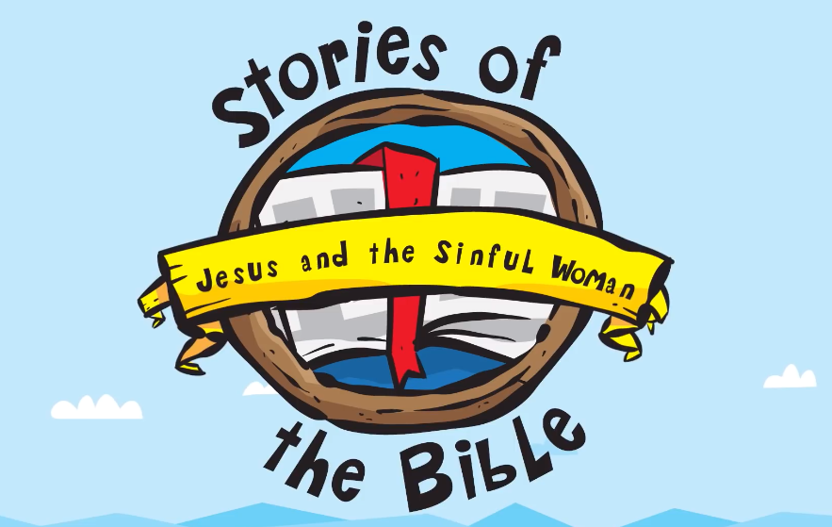

5. QUIZ
- What did this woman do to Jesus’ feet?

- What did Simon NOT do for Jesus, who was his guest at dinner?

- Jesus told Simon the story of the two men. Both had their debt forgiven. What does this mean for them?

- When we behave badly, why should we say “sorry” to God?

6. ACTIVITIES

- Jesus Forgives a Woman Colouring Page (see attached file)
  - Hint: After colouring this, spray some perfume onto the page.

7. CLOSING PRAYER
Thank you God, for your son Jesus and the special story he told Simon.

Saying “sorry” is so important for us, to have peace, joy and friendship with God.

We thank you that you will always forgive us for our bad behaviour and thoughts, when we admit these faults to you.

Thank you for being our Friend. Help us to know you more and to love other people as you love them.

AMEN.

