AMPT Sunday 15 August 2021
2 Samuel 11:1-12:15
Welcome to Ampt with Ruth, thank you for looking at this Bible passage with me. Even though we are in lock down once again, let’s remember all the good things in our life to thank God for.
Prayer Dear Lord Jesus, thank you that you love us no matter what, and that you are always ready to forgive any wrong doings when we are truly sorry. Please help us to understand and learn from today’s Bible passage. In Jesus’ name, Amen.
Review Last week we looked at 2 Samuel 9. Can you remember the very kind action of King David?
Video
Story of David and Bathsheba - YouTube
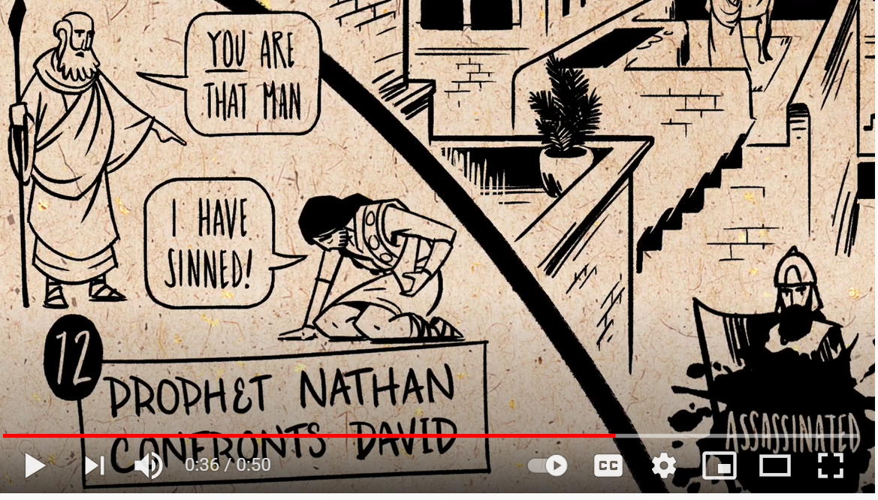

Dramatic Bible story based on 2 Samuel 11 and 12
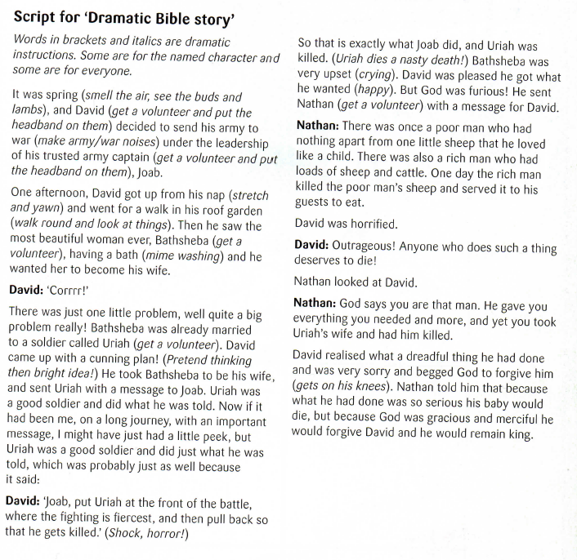
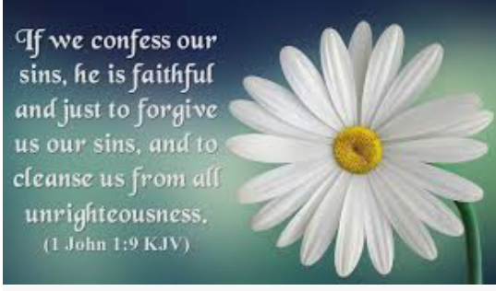
King David took something that didn’t belong to him, Uriah’s wife, and he killed Uriah to get her. Eventually David acknowledged the terrible thing that he had done. He was very sorry and begged God to forgive him. God forgave him, but there were consequences for David and his family.
Q1. What did David do when he realised what a terrible thing that he had done?
Q2. What was God’s response?

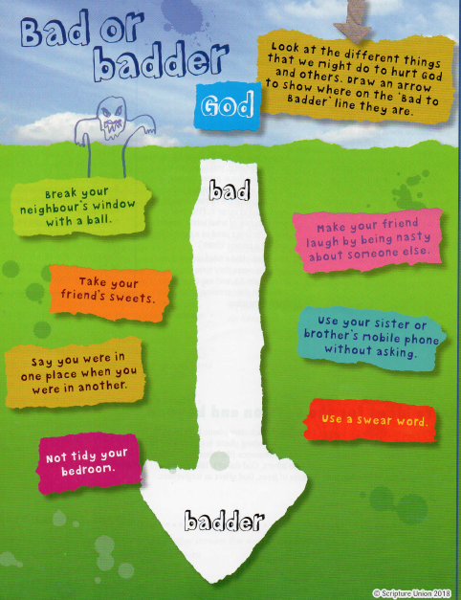
It may seem that some sins are worse than others, but as far as God is concerned, they are all as bad as each other, and all are wrong. The good news is that God offers forgiveness.
Prayer Dear Lord Jesus, please help us to make good choices in everything that we do and say and forgive us for the wrong that we do. Thank you that you love us no matter what. In Jesus’ name, Amen. 