AMPT Sunday 17 October 2021
Welcome to Ampt with Ruth
Prayer
Dear Lord Jesus, we thank you that you created us to be your friends and that you love us so much. Please help us to understand the Bible passages that we are looking at today. In Jesus’ name, amen.
Review
Last week we learnt that we are often busy doing good things but Jesus wants us to spend time learning from him and getting to know him.
Introduction
The Bible teaches that God loves all people and wants us to know and love him. God sent his son Jesus to make this possible. Today’s lesson teaches us the way to God, and what you could choose to pray if you want to become a Christian.
Video
The Bridge to Life Animated - YouTube
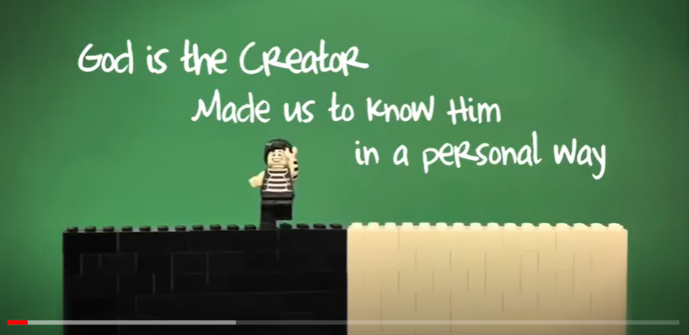
Bible passages

John 3:16
¹⁶ For God so loved the world that he gave his one and only Son, that whoever believes in him shall not perish but have eternal life.

Isaiah 59:2

But your iniquities have separated
you from your God;
your sins have hidden his face from you,
so that he will not hear.

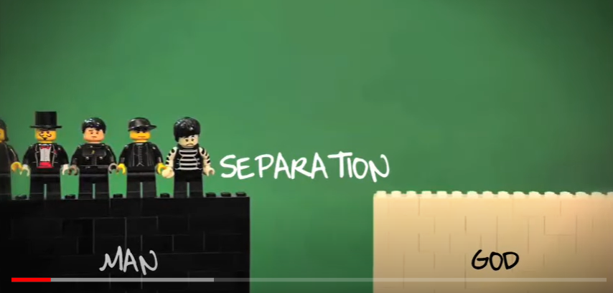
Romans 3:23
²³ For all have sinned and fall short of the glory of God.
1 Peter 3:18
¹⁸ For Christ also suffered once for sins, the righteous for the unrighteous, to bring you to God. He was put to death in the body but made alive in the Spirit.

1 Timothy 2:5
⁵ For there is one God and one mediator between God and mankind, the man Christ Jesus,
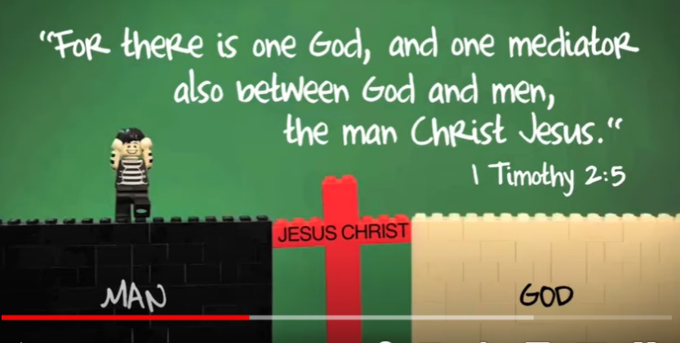

John 1:12
¹² Yet to all who did receive him, to those who believed in his name, he gave the right to become children of God—
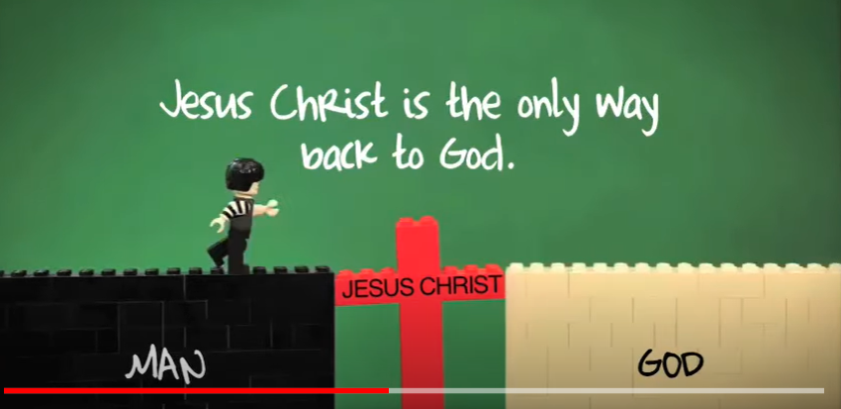

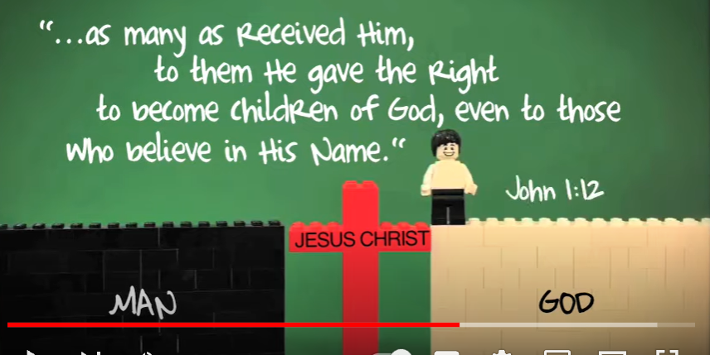

Questions
- Why are people separated from God and His Love? (See Isaiah 59:2)
- What did Jesus do to bring us to God? (See John 3:16 and 1 Peter 3:18)
- How can we become children of God? (See John 1:12)

Prayer
If you choose to pray this prayer sincerely, please talk to your parents and let your Kids Church leaders know. We will be so happy to know that you have accepted Jesus as your Saviour and asked Him to be in charge of your life.

Lord Jesus,
I confess I am a sinner.
I want to trust you as my saviour and obey you as my Lord.
Please forgive my sins and give me the gift of eternal life.
Thank you for providing the way to God.
Amen.

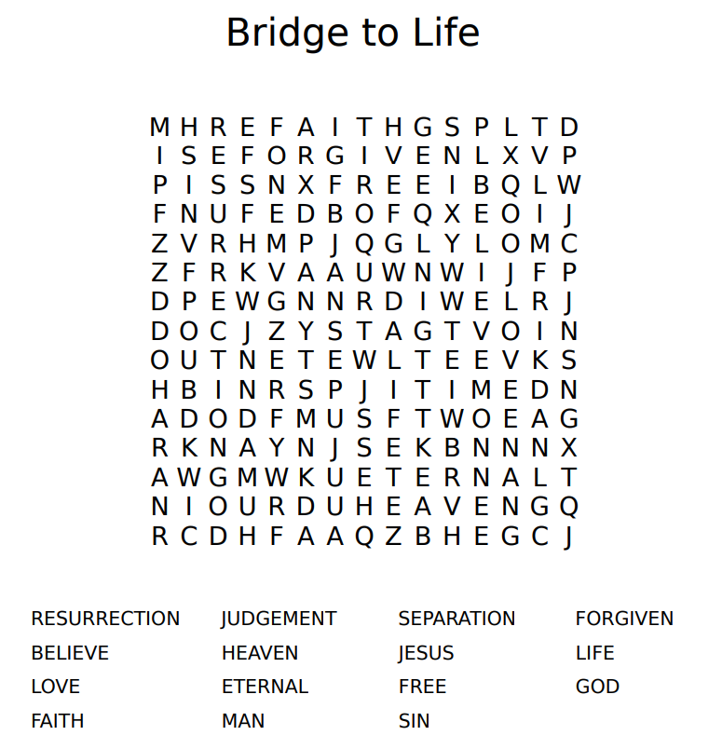
Word search

